Bài khảo sát, đánh giá năng lực gồm có  02 trang | BÀI KHẢO SÁT, ĐÁNH GIÁ NĂNG LỰC HỌC SINH  Tuyển sinh vào lớp 6 năm học 2026 – 2027  Nội dung: NĂNG LỰC TIẾNG ANH  Học sinh làm bài trên bài thi này:

A.PHẦN TRẮC NGHIỆM
I. Choose the best answer A, B, C or D
- Which underlined part has the sound different from the others ?
A. visits B. stops C. cooks D.runs
- Which word has stress different from the others?
A. building B. children C. garden D. fourteen
- My mother told _________ a story last night.
A. me B. I C. my D. mine
- ________ orange juice does she drink a day?
A. How much B. How long C. How many D. How often
- They __________ a book now.
A. reading B. is reading C. read D. are reading
- Mrs Hoa always ______ a bus to work.
A. takes B. catches C. drives D. has
- Our final exam will take place ____ Friday, May 29th 2026.
A. at B. in C. on D. to
- I’m going to the ______ now. I want to send a letter.
A. post office B. drug store C. supermarket D. book store
- She is 150cm _______.
A. tall B. height C. heavy D. weigh
- There are ______ pencils in the pencil case.
A. any B. much C. many D. a
- Tony: “Mary, may I borrow your pen?”
Mary: “ _______________”.
A.No, thanks B. Sure. Here you are C. Yes, please D. Yes, thanks
- A: “Whose book is this ?”
B: “It’s __________”.
A.our B. her C. mine D. Ben
- The person who takes care of animals is a ________.
A. firefighter B. teacher C. vet D. chef
- I love ______ the piano after school because it helps me relax
A. playing B. taking C. doing D. having
- Read the notice and choose the correct statement.
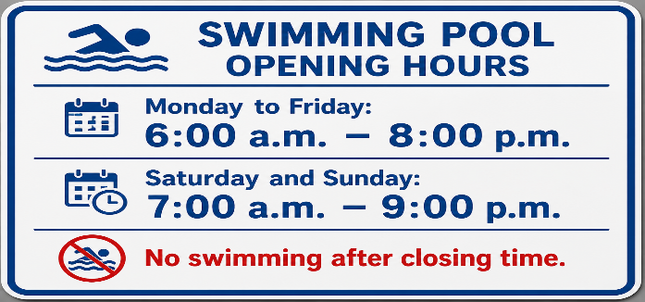
- The swimming pool opens at 8:00 a.m on weekdays.
- People can swim after 9:00 p.m on Sunday.
- The swimming pool closes at 8:00 p.m. from Monday to Friday.
- The pool is closed on weekends.
- Stranger: “ Excuse me, can you tell me where Hoang Xuan Han Secondary School is, please ?”
Mai : “ _______________”.
- Yes, please. B. Sorry, I’m new here myself.
C. Sure, go ahead. D. OK. Here’s your ticket.
- PHẦN TỰ LUẬN
I.Rewrite each sentence using the word given in brackets without changing its meaning
( Viết lại mỗi câu sau đây sử dụng từ cho sẵn trong ngoặc mà không làm thay đổi nghĩa của nó)
1. I brush my teeth in the morning and in the evening everyday. (twice)
→ ____________________________________ .
- What’s your date of birth ? (birthday)
→ ____________________________?
II. Use the words given to complete the sentences
- going/visit/summer/I/this/am/Thien Cam Beach/holiday/to
→ _________________________________________________________.
- dentist/a/when/you/to/should/You/the/toothache/go/have
→ _____________________________________________________.

A.PHẦN TRẮC NGHIỆM

I. Choose the best answer A, B, C or D
- Which underlined part has the sound different from the others ?
A. visits B. stops C. cooks D.runs
- Which word has stress different from the others?
A. building B. children C. garden D. fourteen
- My mother told _________ a story last night.
A. me B. I C. my D. mine
- ________ orange juice does she drink a day?
A. How much B. How long C. How many D. How often
- They __________ a book now.
A. reading B. is reading C. read D. are reading
- Mrs Hoa always ______ a bus to work.
A. takes B. catche C. drives D. has
- Our final exam will take place ____ Friday, May 29th 2026.
A. at B. in C. on D. to
- I’m going to the ______ now. I want to send a letter.
A. post office B. drug store C. supermarket D. book store
- She is 150cm _______.
A. tall B. height C. heavy D. weigh
- There are ______ pencils in the pencil case.
A. any B. much C. many D. a
- Tony: “Mary, may I borrow your pen?”
Mary: “ _______________”.
A.No, thanks B. Sure. Here you are C. Yes, please D. Yes, thanks
- A: “Whose book is this ?”
B: “It’s __________”.
A.our B. her C. mine D. Ben
- The person who takes care of animals is a ________.
A. firefighter B. teacher C. vet D. chef
- I love ______ the piano after school because it helps me relax
A. playing B. taking C. doing D. having
- Read the notice and choose the correct statement.
A.The swimming pool opens at 8:00 a.m on weekdays.
- People can swim after 9:00 p.m on Sunday.
- The swimming pool closes at 8:00 p.m. from Monday to Friday.
- The pool is closed on weekends.
- Stranger: “ Excuse me, can you tell me where Hoang Xuan Han Secondary School is, please ?”
Mai : “ _______________”.
- Yes, please. B. Sorry, I’m new here myself.
C. Sure, go ahead. D. OK. Here’s your ticket.

ĐÁP ÁN

- PHẦN TỰ LUẬN
I.Rewrite each sentence using the word given in brackets without changing its meaning
( Viết lại mỗi câu sau đây sử dụng từ cho sẵn trong ngoặc mà không làm thay đổi nghĩa của nó)
1. I brush my teeth in the morning and in the evening everyday. (twice)
→ ____________________________________
- What’s your date of birth ? (birthday)
→ ____________________________
II. Use the words given to complete the sentences
- going/visit/summer/I/this/am/Thien Cam Beach/holiday/to
→ _________________________________________________________
- dentist/a/when/you/to/should/You/the/toothache/go/have
→ __________________________________________________________.

